DR. AMBEDKAR COLLEGE, DEEKSHABHOOMI, NAGPUR,

DEPARTMENT OF LAW
ACADEMIC SESSION 2021-22
NAME OF PROGRAMME: | Guest lecture on the topic “Manufacturer/Seller Beware: Product liability of manufactures in case of goods and services”
DATE AND DAY: | 25th November 2021
TIME: | 11. 00 AM
VENUE: | Virtual
GOOGLE MEETING LINKS: | https://meet.google.com/fgj-xdby-evj
PROGRAMME SUPERVISOR: | Mrs. Vaishali A. Sukhdeve
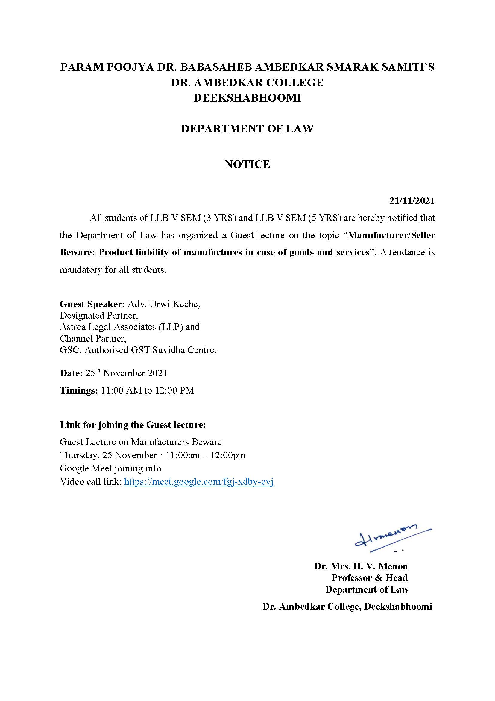
On 25th November 2021, a Guest lecture was organised by the Department of Law of Dr. Ambedkar College, Deekshabhoomi, Nagpur on the topic “Manufacturer/Seller Beware: Product liability of manufactures in case of goods and services” for the students of V Semester (BA. LLB 5 Years and LLB 3 Years course). This guest lecture was conducted through Google meet link at 11.00 AM. Total 66 students attended the guest lecture.
Adv. Urwi Keche, Designated Partner, Astrea Legal Associates (LLP) and Channel Partner, GSC in Authorised GST Suvidha Centre, was invited as a guest speaker to deliver lecture on the topic “Manufacturer/Seller Beware: Product liability of manufactures in case of goods and services”.
Adv. Urwi Keche started the session with emphasising on how consumers are deceived through false advertisements and ultimately suffer the harm or injury well-defined in the New Consumer Protection Act, 2019. She highlighted that how the concept of “Caveat emptor” is now shifted to the concept of “Caveat Vendor” meaning “Let the seller Beware”. Through this concept, she explained that the Manufacture is held liable if he does not provide sufficient warnings to the consumer. He cannot take a plea that the consumer should have been more aware while purchasing the same.
Adv. Keche further explained this by giving different illustrations of how a manufacturer can be held liable for Product liability. Prior to 2019, India did not have a specific legal regime relating to product liability. She informed the students that product liability claim was lodged within the existing laws of contract and torts and many claims were founded and derived from legislations such as the Sale of Goods Act, 1930; the Consumer Protection Act, 1986; and the Indian Contract Act, 1872. These claims were also based on case laws, both in the civil and criminal aspects, leading to much confusion and different approaches. Until recently, there was no comprehensive legislation to cover the aspect of product liability.
Adv. Keche updated that the Consumer Protection Act 2019 provides for new provisions of product liability and an action can be filed against a ‘product manufacturer’ or a ‘product service provider’ or a ‘product seller’, as the case may be. She further added that the Product manufacturers, sellers and service providers will need to ensure that they have done their due diligence properly to be compliant with the various requirements under different legislations.
She concluded her lecture by mentioning that the compliances backed with proper legal and technical assistance would definitely help in protecting the interest of vendor and the interest of the consumers as well. This was followed by the question answer session. The speaker answered all the queries of the students relating to the manufacturer, seller and service providers role and the extent of their liability in detail to the satisfaction of the students. The program was conducted and co-ordinated by Mrs. Vaishali A. Sukhdeve under the able guidance of Head of the Department, Prof. Dr. Mrs. H.V. Menon.
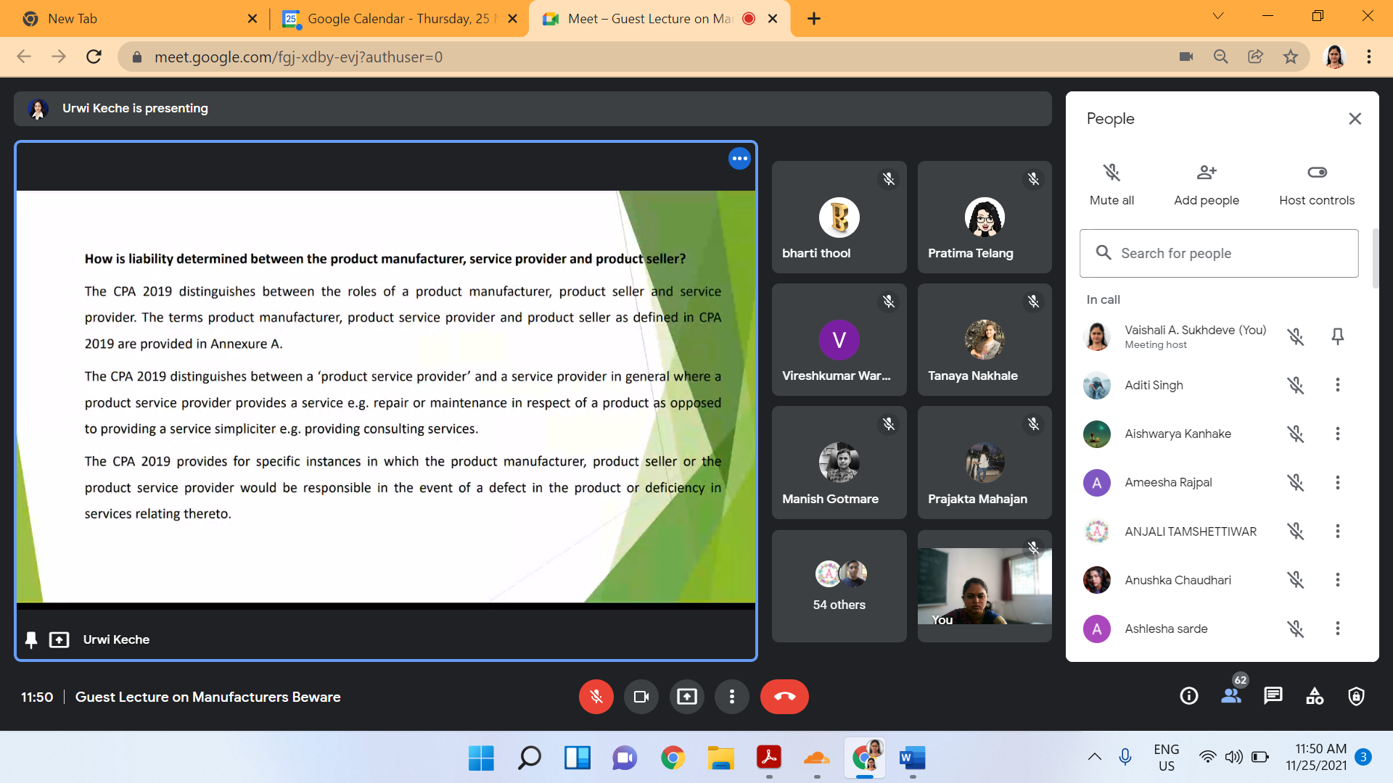
Guest speaker Adv. Urvi Keche explaining the students about the new shift of concept of Consumerism by highlighting the manufacturer, seller and service providers role
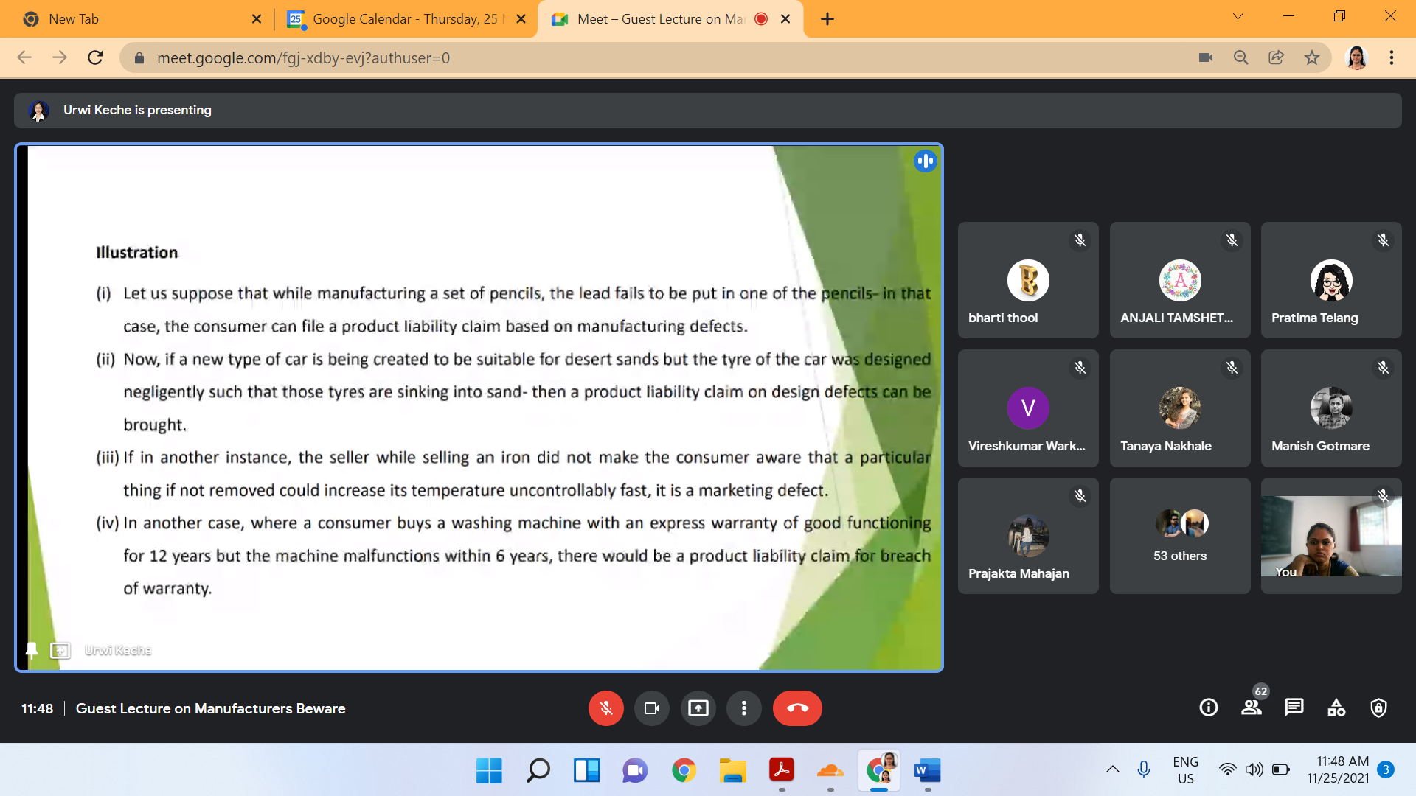
Guest speaker explaining through examples the liability of manufacturer, seller and the service providers.

